Jenkins -01

- Install Jenkins and run Jenkins on port number 8081.

- Installed Jenkins on the server using appropriate package manager.
- Started Jenkins service and verified its running status.
- Modified Jenkins configuration to run on custom port 8081.
- Restarted Jenkins service to apply port changes.
- Accessed Jenkins UI via browser
- Completed initial setup using admin password and installed suggested plugins.

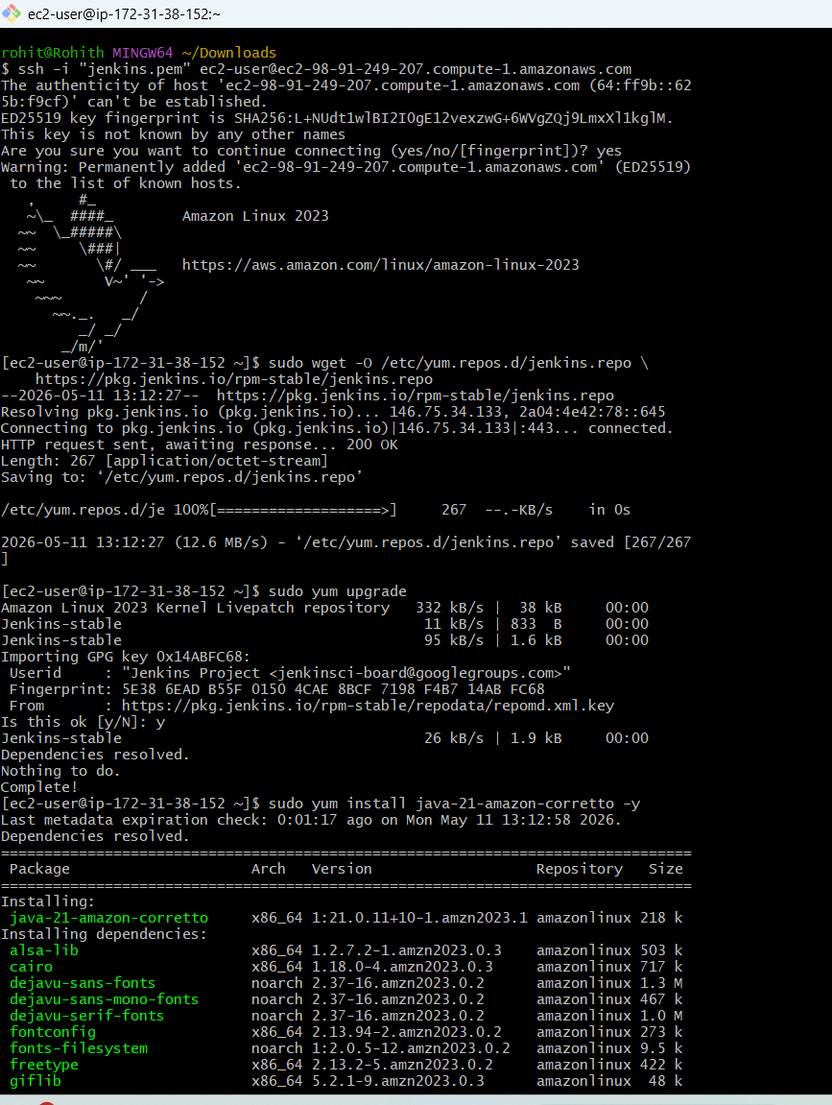

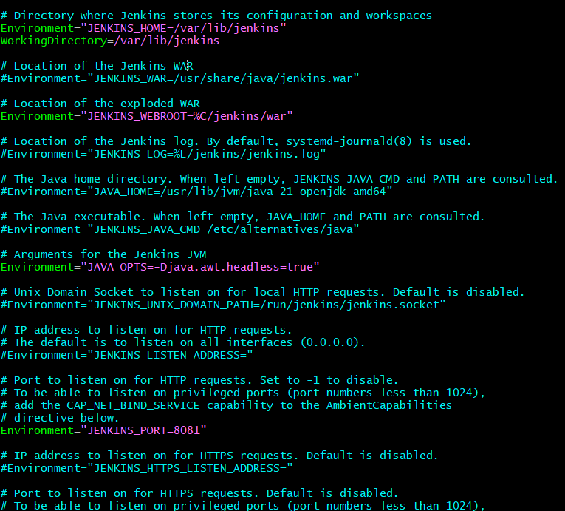
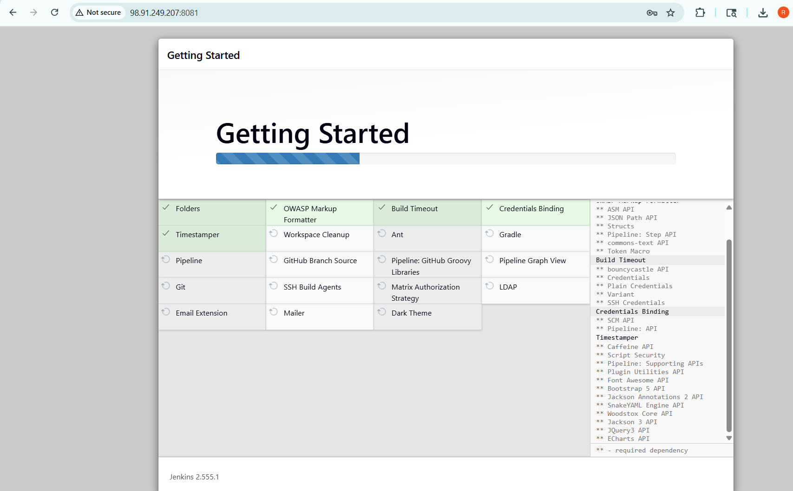

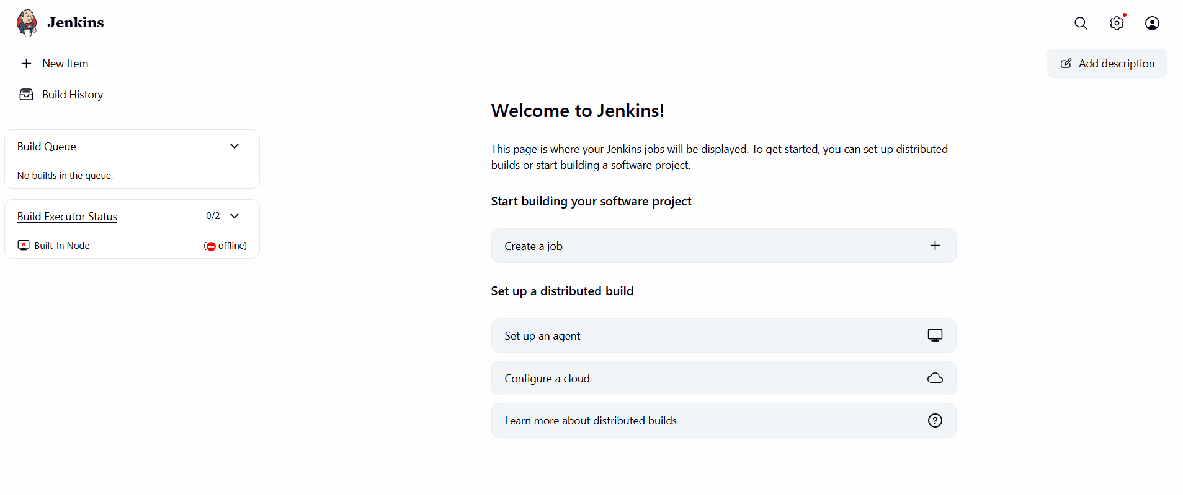

- Secure Jenkins server

Enabled Jenkins security by configuring authentication and authorization settings.
Restricted access by disabling anonymous users and allowing only authenticated users to log in.
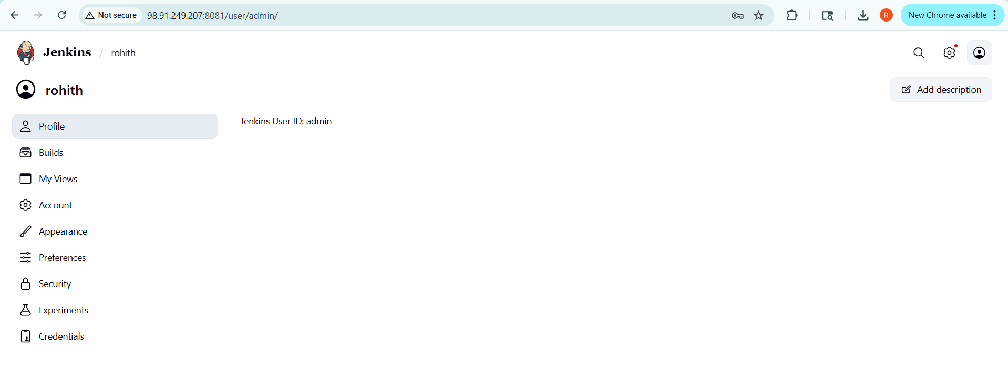

- Create users called DevOps, Testing in Jenkins with Limited access.

Navigated to Jenkins Manage Users section.
Created users: DevOps and Testing.
Assigned secure passwords for both users.
Configured role-based permissions for restricted access.
Limited access to specific jobs/features based on roles.
Tested login with both users to verify access restrictions.

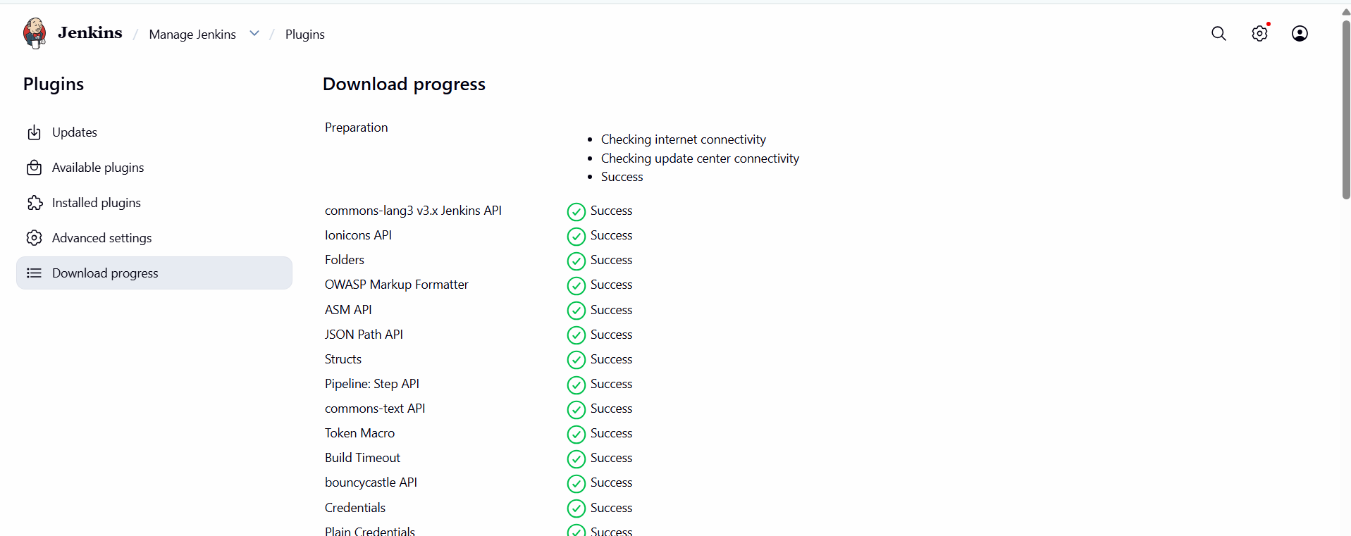

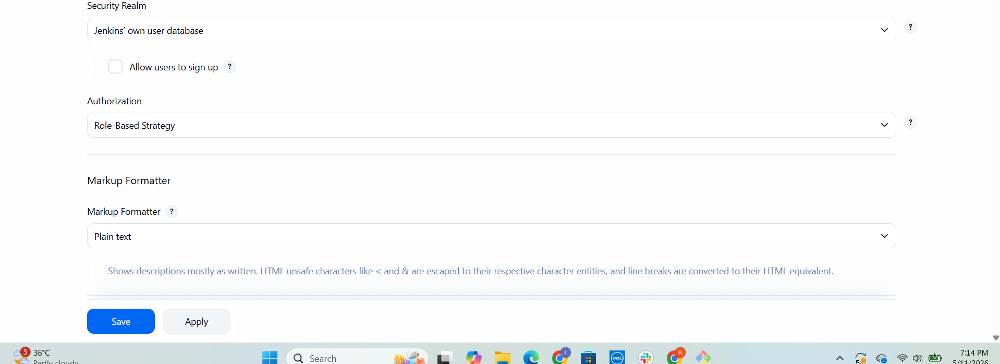

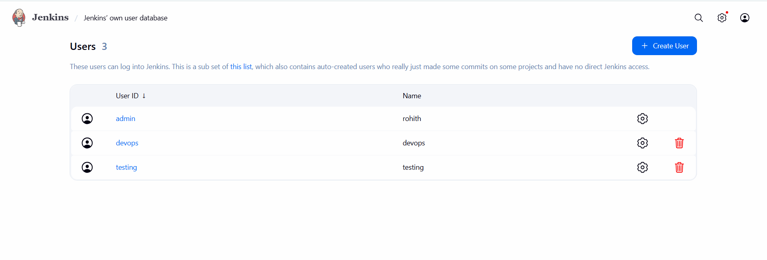

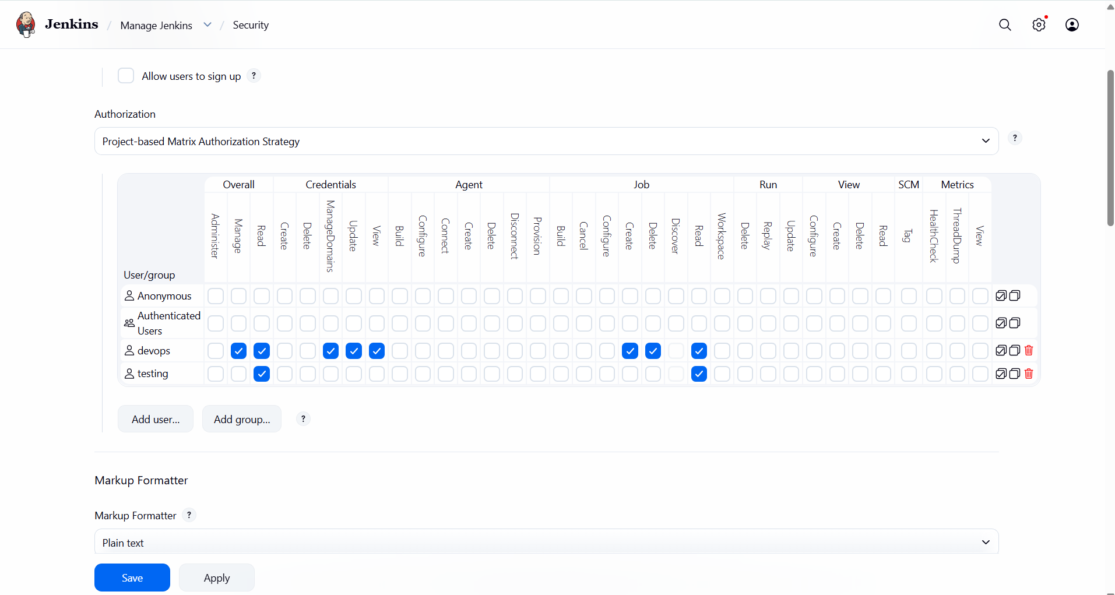

- Configure labels and restrict the jobs to execute based on label only.

Navigated to Jenkins node configuration.
Assigned labels to nodes
Configured node usage settings for controlled execution.
Updated job configurations to use specific labels only.
Ensured jobs run only on intended nodes.
Verified execution by triggering builds and checking node allocation.

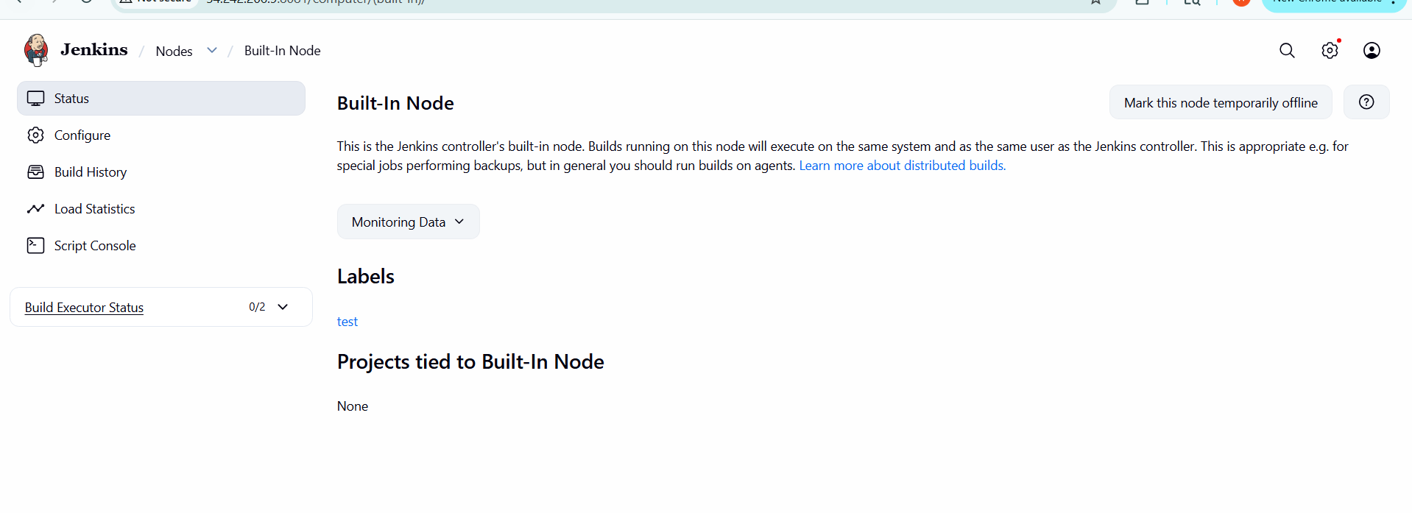

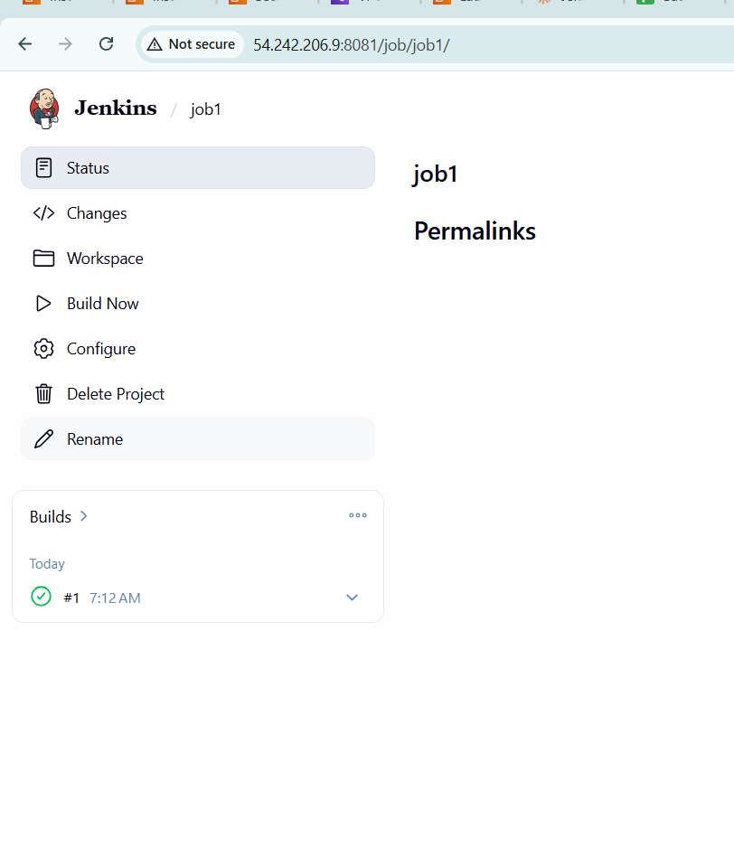
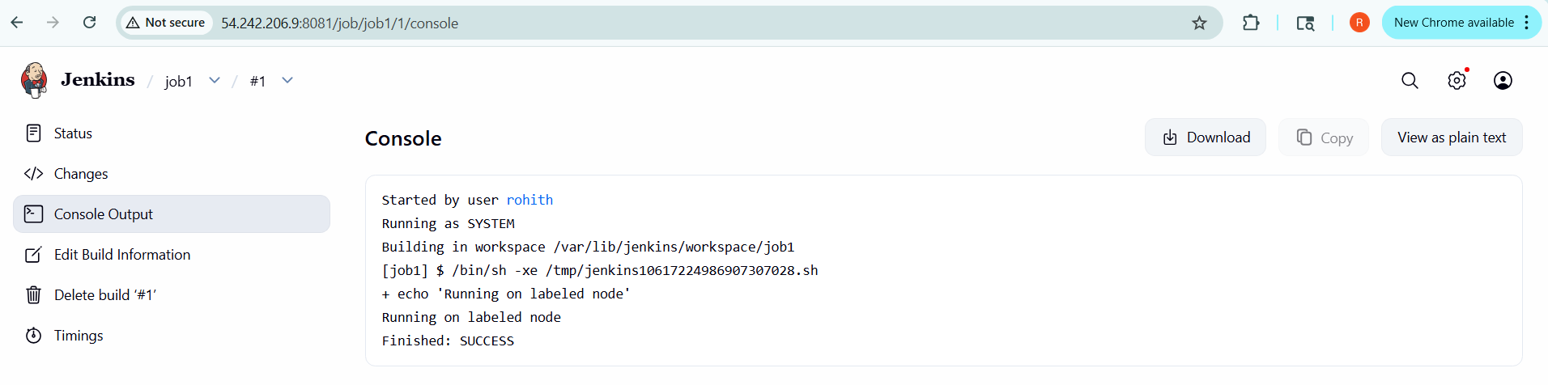

- Create Three sample jobs using the below URL.
Opened Jenkins dashboard and created new jobs.
Selected Freestyle project for job creation.
Configured GitHub repository URL
(https://github.com/betawins/Techie_horizon_Login_app.git)
Set up build triggers and basic build steps.
Executed jobs manually to verify functionality.
Checked console output to ensure successful build completion.

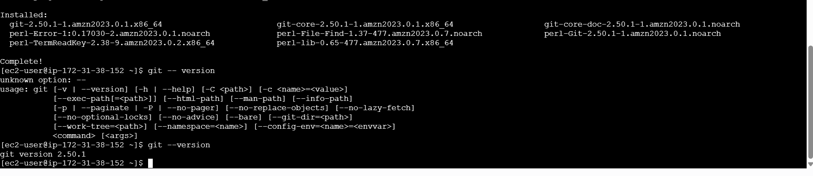

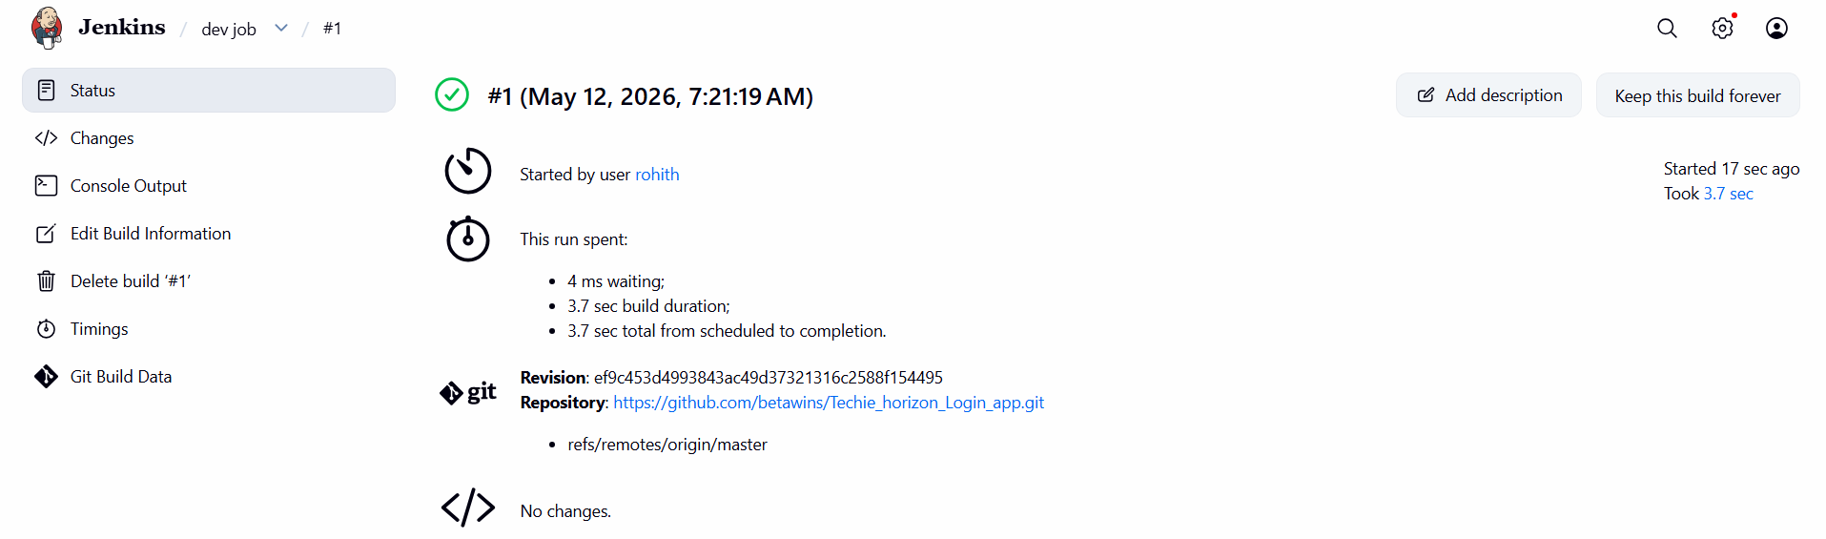

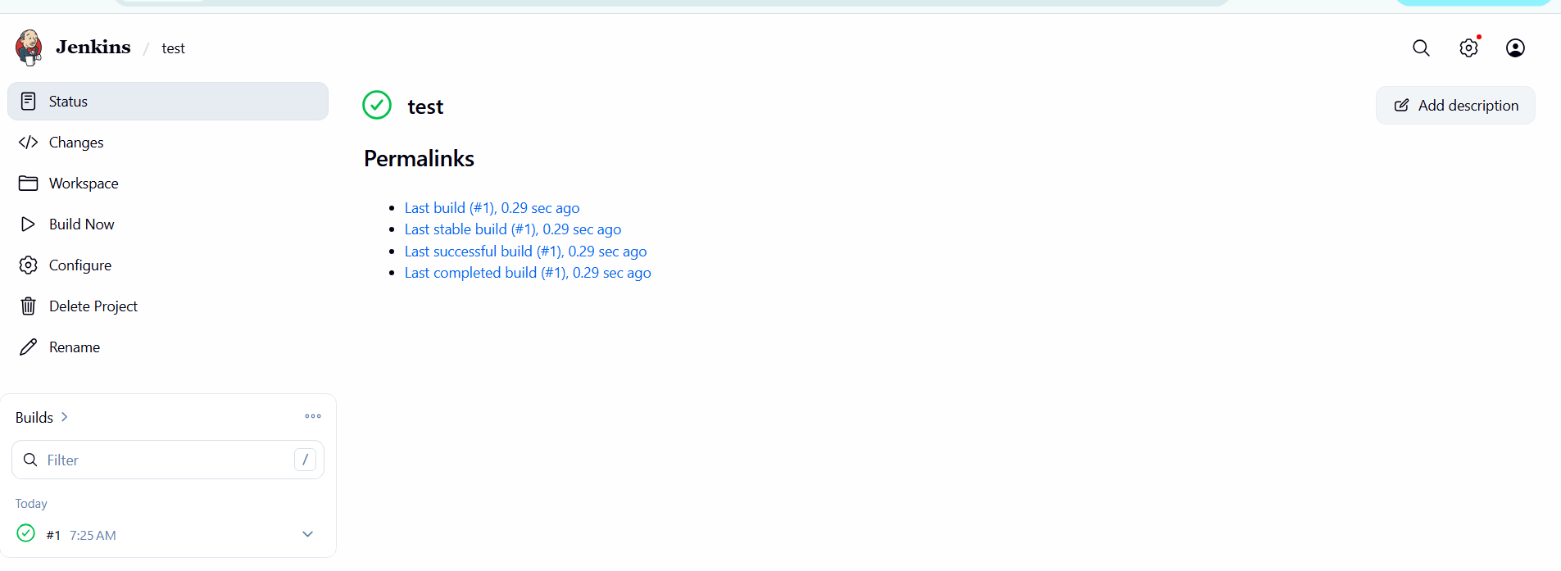

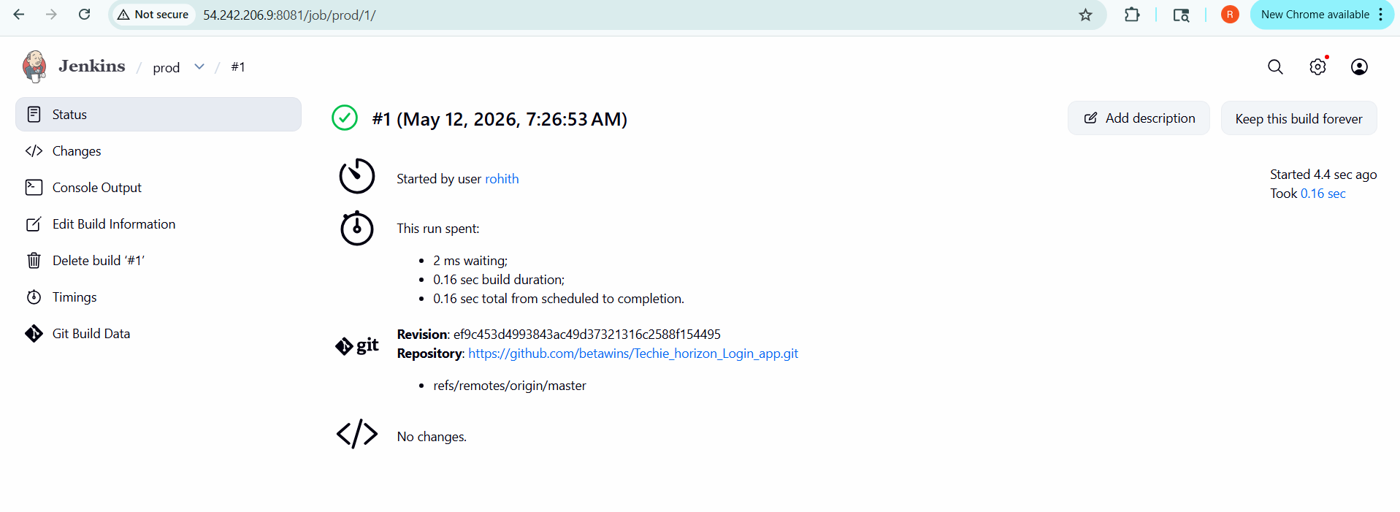
- Create one Jenkins job using GitHub Private repository.
Generated GitHub credentials (username/token or SSH key).
Added credentials securely in Jenkins credentials manager.
Created a new Jenkins job for private repository.
Configured repository URL with authentication.
Executed build to validate secure access to repo.
Verified successful build and repository integration.

